

JAVA PROJECT REPORT ON
SEMESTER GPA AND CGPA CALCULATION SYSTEM

Submitted by
ELAKKIYA SUDHA .A
25BIT108

Under the Guidance of
Mr. R.Mugilan
Technical Trainer
Technical Department, KG College of Arts and Science

Academic Year: 2025 – 2026
APRIL 2026
Semester: II

DECLARATION
I hereby declare that the project entitled “SEMESTE GPA AND CGPA” submitted in partial fulfillment of the requirements for the course Java Programming is a record of my original work carried out under the guidance of Mr.R.Mugilan, Technical Trainer, Technical Department, KG College of Arts and Science.
I further declare that this project has not been submitted previously, either in part or in full, for the award of any degree, diploma, or other similar title, at this or any other institution.
I have acknowledged all sources of information used in this project wherever applicable.

April 2026
Coimbatore

________________________
Elakkiya Sudha.A

CERTIFICATE
This is to certify that the project entitled “SEMSTER GPA AND CGPA CALCULATION SYSTEM” is a bona fide work carried out by ELAKKIYA SUDHA.A IstYEAR , B, Inforamtion Technology, KG College of Arts & Science, in partial fulfillment of the requirements for the course Java Programming.
This project has been completed under my supervision and guidance during the academic period April 2026.

Place: Coimbatore
Date:

Submitted for the Viva-Voce Examination held on __________________________________

Guide: Head of the Department
(Technical Trainer, KGCAS) (Technical Head, KGCAS)
________________________ _______________________

TABLE OF CONTENTS
S. No. | Topics | Page. No.
1 | Introduction
1.1 | Objective
1.2 | Overview
1.3 | Features
2 | Program Analysis
2.1 | Problem Definition
2.2 | Project Overview
2.3 | Scopes and Limitations
3 | System Design
3.1 | Modules
4 | Methodology
4.1 | Problem Analysis
4.2 | System Design
4.3 | Program Development
4.4 | Testing and Validation
4.5 | Result and Documentation
4.6 | Algorithm
4.7 | Flowchart
5 | Source Code
6 | Input and Output Screens
7 | Discussion and Conclusion
7.1 | Discussion
7.2 | Conclusion
8 | References

ABSTRACT
The Semester GPA and CGPA Calculator is a Java-based application developed to simplify the process of calculating academic performance metrics for students. The system allows users to input subject grades and corresponding credit hours for each semester, and it computes the Grade Point Average (GPA) for a specific semester as well as the Cumulative Grade Point Average (CGPA) across multiple semesters.
The application is designed with a user-friendly interface and follows standard GPA calculation formulas to ensure accuracy and consistency. It reduces manual errors and saves time compared to traditional calculation methods. The program demonstrates the use of core Java concepts such as classes, methods, loops, arrays, and user input handling.
This project is useful for students and educational institutions to efficiently track academic progress and performance over time. It also serves as a practical example of applying programming skills to solve real-world problems in the academic domain.

1.INTRODUCTION
The Semester GPA and CGPA Calculator is a Java-based application designed to assist students in evaluating their academic performance efficiently. In many educational institutions, calculating GPA and CGPA manually can be time-consuming and prone to errors. This project automates the process by allowing users to input grades and credit values, and then accurately computes the results.
The system is developed using core Java programming concepts and provides a simple and interactive way for students to monitor their progress. It serves as a practical tool for both academic use and learning programming fundamentals.
1.1 Objective
To develop a Java application for calculating Semester GPA and overall CGPA.
- To reduce manual calculation errors and improve accuracy.
- To provide a simple and user-friendly interface for users.
- To apply core Java concepts such as arrays, loops, and functions in a real-world application.
- To help students track their academic performance easily.
1.2 Overview
This project focuses on creating a calculator that computes GPA for a single semester and CGPA across multiple semesters. The user inputs subject grades and credit hours, and the system processes this data using predefined formulas.
The application works by converting grades into grade points, multiplying them with credit hours, and then calculating the average. For CGPA, it aggregates GPA values from multiple semesters. The system ensures accuracy and consistency while minimizing user effort.
1.3 Features
- Automatic calculation of Semester GPA
- Calculation of overall CGPA across semesters
- Simple and user-friendly interface
- Error reduction compared to manual calculations
- Fast and efficient processing
- Can handle multiple subjects and semesters

2.PROGRAM ANALYSIS
The Semester GPA and CGPA Calculator program is designed to analyze student academic data and produce accurate results based on input values. The program takes subject grades and corresponding credit hours as input, converts grades into grade points, and performs calculations using standard GPA formulas.
The analysis involves validating user inputs, ensuring correct grade-point mapping, and applying mathematical operations such as multiplication and averaging. The program uses control structures like loops and conditional statements to process multiple subjects and semesters efficiently. Overall, the system ensures reliability, accuracy, and ease of use.
2.1 Problem Definition
In educational institutions, students often need to calculate their GPA and CGPA to assess their academic performance. Manual calculation can be complex, time-consuming, and prone to errors, especially when dealing with multiple subjects and semesters.
The problem is to develop a system that automates the calculation process, reduces errors, and provides quick and accurate results. The solution should be simple, efficient, and accessible to users without requiring advanced technical knowledge.
2.2 Project Overview
The Semester GPA and CGPA Calculator is a Java-based application that simplifies academic performance evaluation. It allows users to input grades and credit hours for each subject and calculates the GPA for a semester as well as the CGPA across multiple semesters.
The project is built using basic Java programming concepts such as classes, methods, arrays, and loops. It provides a structured approach to handle input, process data, and display results clearly. The application can be used by students to monitor their academic progress throughout their course.
2.3 Scopes and Limitations
Scope:
- Can be used by students in schools and colleges
- Supports calculation of GPA for individual semesters
- Calculates CGPA across multiple semesters
- Helps in tracking academic performance over time
- Can be further enhanced with graphical user interface (GUI)
Limitations:
- Works based on predefined grading systems only
- Does not support different grading policies automatically
- Limited to basic input/output (console-based program)
- Requires manual entry of grades and credits
- Does not store data permanently (no database integration)

3 . SYSTEM DESIGN
The Semester GPA and CGPA Calculator is designed using a simple and modular approach to ensure clarity and ease of implementation. The system follows a structured flow where the user provides input, the program processes the data, and the results are displayed.
The design consists of three main components:
- Input Design
The system accepts user inputs such as number of subjects, grades, and credit hours. Input validation is considered to ensure correct data entry.
- Processing Design
The program converts grades into grade points and calculates GPA using the formula:
GPA = (Sum of (Grade Point × Credit)) / Total Credits
For CGPA, it averages the GPA values of multiple semesters.
- Output Design
The calculated GPA and CGPA are displayed clearly to the user. The output is formatted for easy understanding.
The system is implemented using Java concepts such as classes, methods, loops, arrays, and conditional statements. The design ensures that the program is simple, efficient, and maintainable.
3.1 Modules
The project is divided into smaller functional units (modules) for better organization and readability:
- Main Module
  - Controls the overall flow of the program
  - Displays menu options
  - Calls appropriate functions for GPA and CGPA calculation
- Input Module
  - Handles user input for number of subjects, grades, and credits
  - Stores input values in arrays or variables
- Grade Conversion Module
  - Converts letter grades (A, B, C, etc.) into corresponding grade points
  - Uses conditional statements or switch cases
- GPA Calculation Module
  - Calculates Semester GPA using grade points and credit values
  - Performs multiplication and averaging operations
- CGPA Calculation Module
  - Calculates overall CGPA based on multiple semester GPAs
  - Maintains cumulative results
- Output Module
  - Displays calculated GPA and CGPA
  - Ensures results are presented clearly and neatly

4.METHODOLOGY
The methodology followed in this project is a step-by-step approach to design and develop the Semester GPA and CGPA Calculator. First, the problem is identified and analyzed. Then, the system is designed by dividing it into modules such as input, processing, and output. After designing, the program is developed using Java programming concepts. The developed system is tested with various inputs to ensure accuracy. Finally, the results are documented for evaluation and future improvements.
4.1. Problem Analysis
The main problem is the difficulty in manually calculating GPA and CGPA, which involves multiple subjects, grades, and credit hours. Manual methods can lead to calculation errors and consume time. Therefore, a system is required to automate this process, ensuring accuracy, speed, and ease of use for students.
4.2. System Design
The system is designed using a modular structure:
- Input module to collect grades and credits
- Processing module to calculate GPA and CGPA
- Output module to display results
The design ensures smooth data flow from input to output and uses simple Java constructs like loops, arrays, and functions for implementation.
4.3. Program Development
The program is developed using Java programming language. It uses:
- Arrays to store grades and credits
- Loops to process multiple subjects
- Conditional statements for grade-to-point conversion
- Methods to organize the code into reusable blocks
4.4. Testing and Validation
The program is tested with different sets of inputs to verify correctness. Test cases include:
- Different numbers of subjects
- Various grade combinations
- Edge cases like minimum and maximum values
The output results are compared with manual calculations to ensure accuracy. Errors found during testing are corrected to improve reliability.
4.5. Result and Documentation
The final program successfully calculates Semester GPA and overall CGPA accurately. The results are displayed clearly to the user. Documentation includes details of design, implementation, testing, and results, making it easy to understand and maintain the project.
4.6. Algorithm
Step 1: Start the program
Step 2: Initialize Scanner
Create a Scanner object to take user input
SGPA Calculation
Step 3: Input number of subjects
Read integer n (number of subjects)
Step 4: Initialize variables
Set totalCredits = 0
Set totalPoints = 0
Step 5: Loop through each subject (i = 1 to n)

For each subject:

Display subject number
Input credit
Input grade point
Update total credits:
totalCredits = totalCredits + credit
Calculate and update total points:
totalPoints = totalPoints + (credit × grade)
Step 6: Calculate SGPA
SGPA = totalPoints / totalCredits
Step 7: Display SGPA
CGPA Calculation
Step 8: Input number of semesters
Read integer sem
Step 9: Initialize variable
Set totalSGPA = 0
Step 10: Loop through each semester (i = 1 to sem)

For each semester:
Input SGPA of that semester
Add to total:
totalSGPA = totalSGPA + SGPA
Step 11: Calculate CGPA
CGPA = totalSGPA / sem
Step 12: Display CGPA
Step 13: Close Scanner
Step 14: End the program
4.7. Flowchart
(START)
│
▼
Enter number of subjects
│
▼
Input credit & grade for all subjects
│
▼
Calculate SGPA
│
▼
Display SGPA
│
▼
Enter number of semesters
│
▼
Input SGPA of all semesters
│
▼
Calculate CGPA
│
▼
Display CGPA
│
▼
(END)

5.SOURCE CODE

import java.util.Scanner;
public class SGPAandCGPACalculation{
public static void main(String[] args){
Scanner sc=new Scanner(System.in);
System.out.print("Enter number of Subjects:");
int n=sc.nextInt();
double totalCredits=0,totalPoints=0;
for(int i=1;i<=n;i++){
System.out.println("Subject"+i);
System.out.print("Enter the Credit:");
int credit=sc.nextInt();
System.out.print("Enter the Grade Point:");
int grade =sc.nextInt();
totalCredits+=credit;
totalPoints+=credit*grade;
}
double sgpa=totalPoints/totalCredits;
System.out.println("SGPA="+sgpa);

System.out.println("Enter Number of Semester:");
int sem=sc.nextInt();
double totalSGPA=0;
for(int i=1;i<=sem;i++){
System.out.print("Enter SGPA of semester"+i+":");
totalSGPA+=sc.nextDouble();
}

double cgpa=totalSGPA/sem;
System.out.println("CGPA="+cgpa);

sc.close();
}
}

6.INPUT AND OUTPUT SCREENS

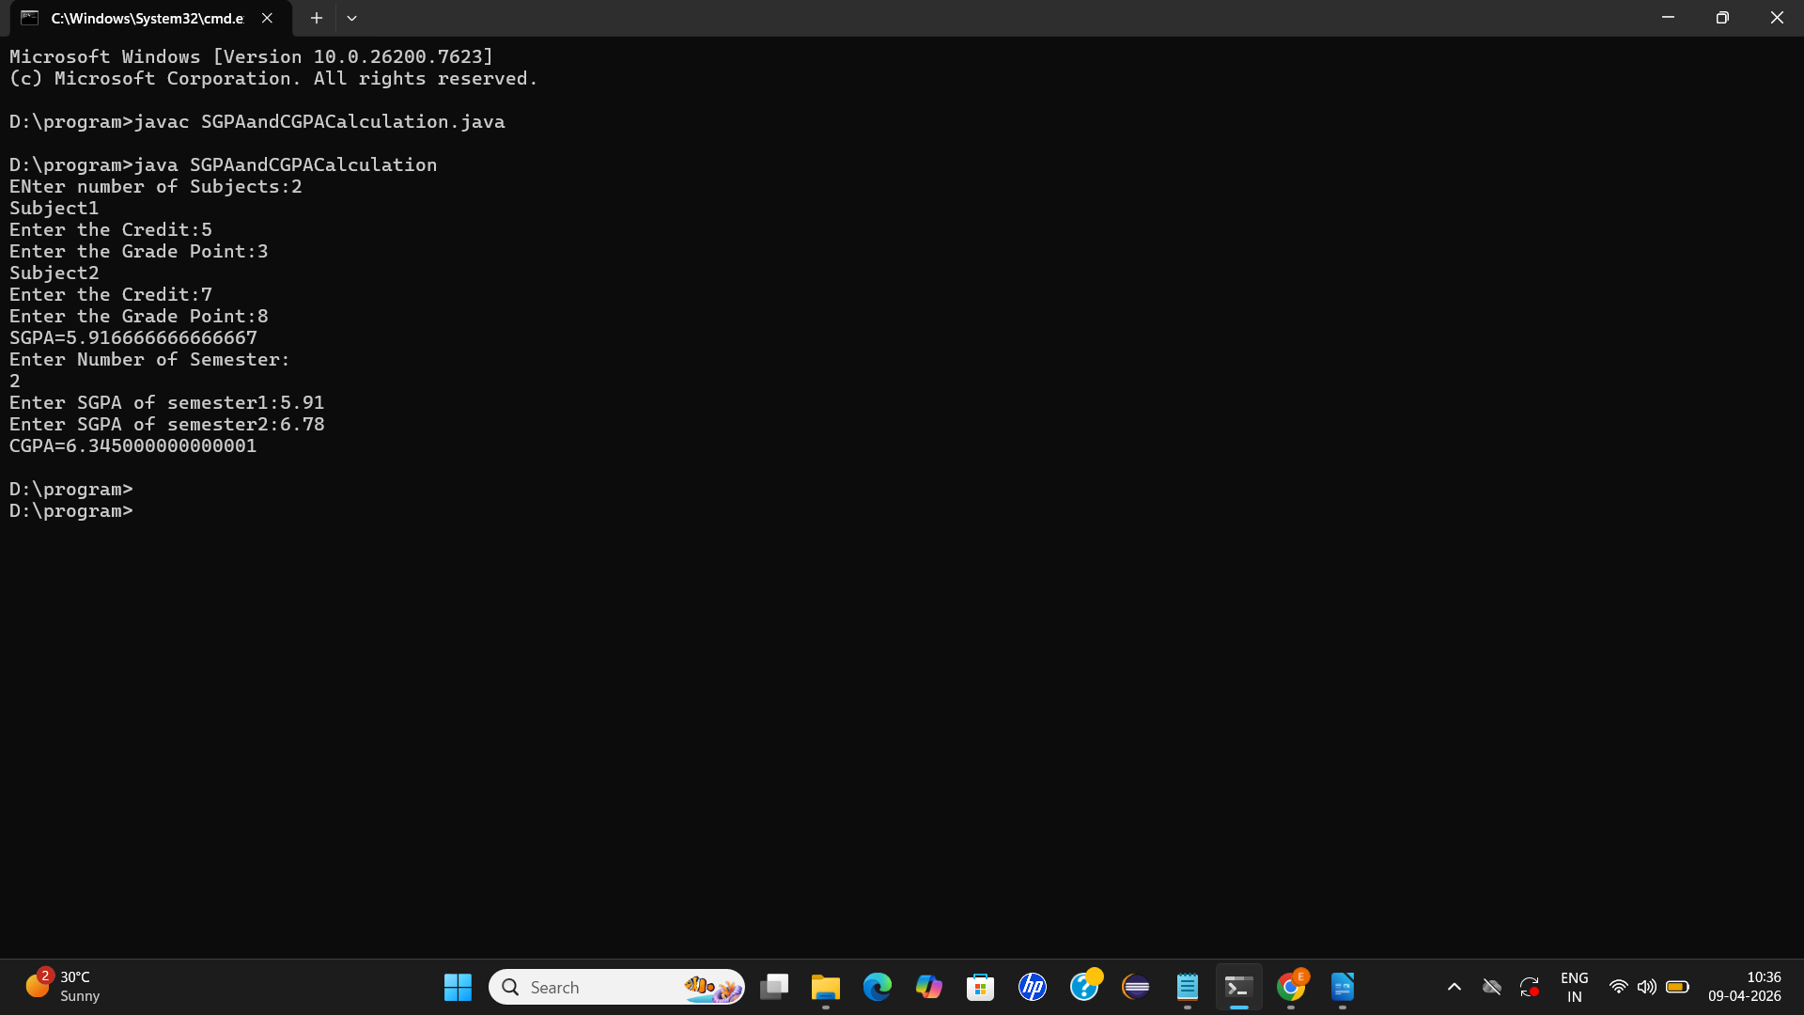

7.DISCUSSION & CONCLUSION

7.1 Discussion
The Semester GPA and CGPA Calculator was developed to simplify and automate the process of calculating academic performance. The program effectively takes user inputs such as subject credits and grade points, processes them using standard formulas, and produces accuate SGPA and CGPA values.
During development, it was observed that using loops and simple arithmetic operations made the program efficient and easy to understand. The modular approach helped in organizing the code and improving readability. Testing with different input values confirmed that the system produces reliable results.
However, the program is console-based and requires manual data entry, which may not be convenient for all users. It also assumes a fixed grading system and does not include advanced features like data storage or graphical interface.

7.2 Conclusion
The project successfully achieves its objective of calculating Semester GPA and CGPA using Java. It reduces manual effort, minimizes errors, and provides quick and accurate results. The application demonstrates the practical use of programming concepts such as loops, arrays, and user input handling.
Overall, the system is simple, efficient, and useful for students to track their academic performance. With further enhancements like a graphical user interface and database integration, the project can be made more user-friendly and scalable for real-world applications.

8.REFERENCES

Herbert Schildt, Java: The Complete Reference, McGraw-Hill Education.
- E. Balagurusamy, Programming with Java, McGraw-Hill Education.
- Oracle, Java Documentation
https://docs.oracle.com/javase/
- GeeksforGeeks, Java Programming Tutorials
https://www.geeksforgeeks.org/java/
- W3Schools, Java Tutorial
https://www.w3schools.com/java/

